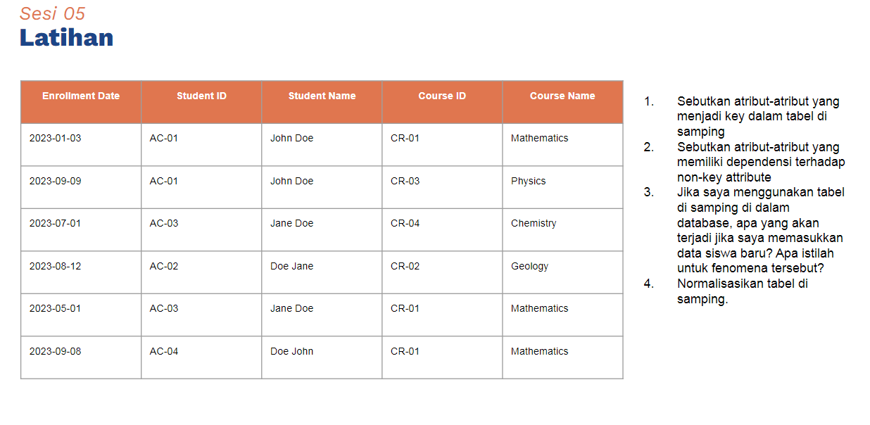

1. key: student id, course id
2. student name, course name
3. insertion anomaly, jika ditambah siswa baru, diperlukan memasukkan course id dan course name, padahal harusnya saat memasuukan siswa baru belum perlu memasukkan data course.
4. normalisasi

|  |  |
| --- | --- |
| Student id | Student name |
| 1 | fulan |

|  |  |
| --- | --- |
| Course id | Course name |
| 1 | mtk |

|  |  |  |
| --- | --- | --- |
| Enroll date | Student id | Course id |
| 2023-01-03 | 1 | 1 |

